 | The Teacher’s Guide  Power Evaluator  Lesson Plan  Evaluating Digital Resources  Investigating the Author  Bias in Digital Resources  Linkto Credibility  Independent Study

Power Evaluator Lesson Plan

This in-depth lesson plan explains how to use the Power Evaluator training as a learning center or in a computer lab. The plan includes the following resources:

- Description of activities
- Alignment to Standards
- DIF Core Competencies
- Goals and Objectives.

The Learning Experiences

Each of the challenge and training experiences in the DIF package provide a real world opportunity to exercise critical thinking that leads to a persuasive essay writing experience. During this training, we ask learners to evaluate digital resources using one of three specific methods of inquiry.

- Investigating the author (Appendix A)
- Bias in Digital Resources (Appendix B)
- Evaluating ‘linkto’ credibility (Appendix C)

This plan provides specific answers and support information for each learning activity so you can make an informed decision about your student’s current skill level.
Power Evaluator Lesson Plan
Introduction:
This lesson plan will help Middle and High School Language Arts Teachers use DIF (Digital Information Fluency) skills with their curriculum. The materials and learning experiences you find here will teach your students to evaluate digital resources. We follow a Challenge / Training / Challenge model. Each learning experience starts with an Evaluation Challenge, and is followed by a self-paced learning experience. These ‘MicroModules’ include a pre and post test to help you assess your student’s knowledge.
Timing:
Depending on the entry level knowledge and skills of the learner, learning experiences can take from 20 to 60 minutes. Should time run short, students can save their word processed documents and return to the lesson at a later time.
Learners:
These learning experiences are aimed at grades 7 -12. We presume students will have basic technology skills. They should be able to:
- navigate the Internet using a browser
- manipulate multiple browser windows
- use a word processor and print documents
Special Needs Accommodations:
Learning materials are written at the 7-8th grade level as measured by the Flesch-Kincaid reading scale. We recommend that students with reading problems work with a higher achieving partner. An audio narration is part of each MicroModule training activity. Reading along with the audio narration will improve reading comprehension for all readers. The Internet materials are 508 compliant. Students using screen readers will be able to navigate the DIF website.
Special Needs Student – Use an Instructional Aide or Mentor to assist with computer and information literacy skills. Additional time could be arranged for special needs students to work in small groups with the resource teacher on this task. Allowing special needs students additional time will be easy to accomplish since these materials are designed to be self-paced.

Gifted Students – Students with advanced skills may be able to successfully challenge the basic learning activities. If so, additional Independent Study modules are available under the Digital Information Fluency Toolkit tab.

Computer and Information Literacy Skilled Students- Ask these students to work as mentors to help others. The mentor benefits by learning to teach skills. This provides the technically skilled information literate student an opportunity to reinforce their abilities by explaining procedures. We often learn best by teaching. Be sure to train your computer mentors to turn over the keyboard to their partners. We learn by doing, not by watching. Emphasize the importance of the learner doing the work. The mentor shouldn’t be doing the keyboarding for the learner.

Digital Information Fluency Core Competencies
Introduction
The 21st Century Information Fluency Project empowers librarians and teachers with the knowledge, skills and dispositions to efficiently locate, evaluate and ethically use digital information resources. As teachers and librarians develop these skills and teach them to students, students will become better equipped to achieve their information needs.
Digital Information Fluency is the ability to find, evaluate and ethically use digital information efficiently and effectively to solve an information problem. This ability involves specific knowledge, skills and dispositions such as knowing how digital information is different from print information; having the skills to use specialized tools for finding digital information; and developing the dispositions needed in the digital information environment.
The Digital Information Fluency (DIF) process is a specific problem-solving model applicable to digital information resources (see Figure 1). It is similar to other iterative problem solving processes such as Big6, the scientific method, or the writing process. DIF is, however, different in that it focuses on specific knowledge and skills applicable to locating, evaluating and integrating digital information into formal and informal learning opportunities. It may be useful for librarians and teachers to embed the DIF process into larger inquiry processes and curriculum projects to help learners to become fluent in locating, evaluating and integrating credible information into their learning activities in an effective and efficient manner.
Overall goal:
Learners will be able to apply the following digital information fluency process, knowledge, skills and dispositions to achieve their information goals.
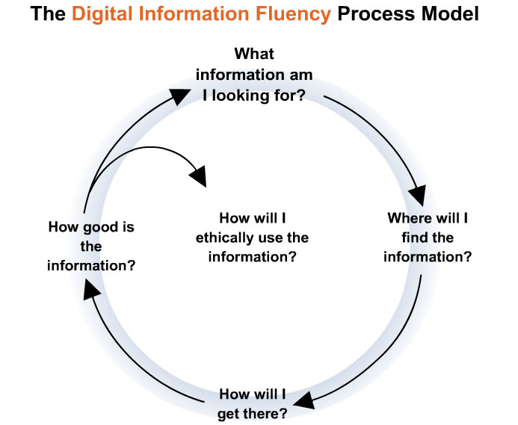

How good is the digital information I found?

Learners evaluate the usefulness and quality of digital Information effectively and efficiently:

- Evaluate the quality of a search result to determine its usefulness in the search process
- Evaluate the quality of a search result to determine the reliability of its content

The following competencies are applicable in all phases of the digital information fluency process:
Learners acquire the dispositions necessary for successful digital information fluency:

- Demonstrate confidence in finding a solution when engaged in the digital information fluency process
- Demonstrate persistence to continually engage in the digital information fluency process
- Demonstrate focus to avoid distractions when engaged in the digital information fluency process
- Demonstrate open-mindedness to a variety of strategies and tools when engaged in the digital information fluency process
- Demonstrate curiosity for exploring ideas when engaged in the digital information fluency process

Learners acquire self-regulation necessary for successful digital information fluency:

- Demonstrate meta-cognitive thinking to adjust their strategies and tools when engaged in the digital information fluency process
- Demonstrate attitude of adaptability to respond to inconclusive or ineffective results when engaged in the digital information fluency process

Frequently Asked Questions Related to Digital Information Fluency
What is Digital Information Fluency?
Digital Information Fluency is the ability to find, evaluate and ethically use digital information efficiently and effectively to solve an information problem. This ability involves knowledge, skills and dispositions such as an understanding the differences between print and digital materials, the skills needed to use specialized tools for finding digital information, and dispositions that enable us to use our knowledge and skills in a the digital information environment.
How is Digital Information Fluency different from Print Information Literacy?

You might think of the similarities and differences this way: digital information fluency is like digital photography. Digital photography is similar in many ways to film-based photography. But anyone who has used a digital camera knows that you have to make adjustments, learn new methods, and think differently to use them efficiently and effectively. The same adjustments, new methods and different ways of thinking are necessary if we want to use digital information resources efficiently and effectively.
Finding, accessing, evaluating and using digital resources is similar in many ways to finding, assessing and using print resources. However there are also important differences. For example, the ability to navigate in a digital hypertext or hypermedia environment is significantly different. Knowing how to search using print reference tools is a helpful foundation for using data base search engines, but isn’t sufficient to ensure efficient and effective use of those digital search tools. Knowing how to evaluate print information is perhaps a stronger preparation for evaluating digital information resources, but the tactics needed to locate author, publisher, and timeliness in the digital information world are significantly different. Incorporating digital information resources into either print or electronic materials require new skills.
How is Digital Information Fluency different from Information Literacy?
There are many definitions of Information Literacy. Some of the broadest definitions include basic literacy skills such as reading and writing as well as advanced skills such as topic definition and communication skills associated with research models such as The Big 6. Digital Information Fluency is not as broad a concept as Information Literacy. DIF focuses on the knowledge, skills and dispositions that people need to locate evaluate and use digital information efficiently and effectively. It includes aspects of both Information Literacy and Technology Literacy. We call it “fluency” rather than “literacy” to emphasize that the abilities involved are more than basic abilities. But we know that there is a spectrum of abilities ranging from basic literacy to the more advanced levels we call fluency.
Why is Digital Information Fluency important?
At home, at school and in the workplace, digital information is beginning to rival print as the primary format for information. Only 2 % of new information being created today appears in print format. As a result, Digital Information Literacy—the ability to access, evaluate and use that information--is fast becoming a skill as essential as traditional print literacy has been. In the 21st century, information enriches our lives, personally, educationally, socially and economically. Those without the skills to use digital information in digital form will become increasingly disadvantaged at home, at school and in the workplace.

Standards:

NETS-S: National Education Technology Standards for Students <http://cnets.iste.org/students/index.shtml>

NETS-S 1. Basic operations and concepts.

- Students demonstrate a sound understanding of the nature and operation of technology systems.

NETS-S 2. Social, ethical, and human issues.

- Students practice responsible use of technology systems, information, and software.
- Students develop positive attitudes toward technology uses that support lifelong learning, collaboration, personal pursuits, and productivity.

NETS-S 3. Technology productivity tools.

- Students use technology tools to enhance learning, increase productivity, and promote creativity.
- Students use productivity tools to collaborate in constructing technology-enhanced models, prepare publications, and produce other creative works.

NETS-S 5. Technology research tools.

- Students use technology to locate, evaluate, and collect information from a variety of sources.
- Students use technology tools to process data and report results.
- Students evaluate and select new information resources and technological innovations based on the appropriateness for specific tasks.

NETS-S 6. Technology problem-solving and decision-making tools.

- Students use technology resources for solving problems and making informed decisions.
- Students employ technology in the development of strategies for solving problems in the real world.

NETS-T: National Education Technology Standards for Teachers < http://cnets.iste.org/teachers/ >
NETS-T I. Technology Operations and Concepts. Teachers demonstrate a sound understanding of technology operations and concepts. Teachers:
- IA. demonstrate introductory knowledge, skills, and understanding of concepts related to technology (as described in the ISTE National Education Technology Standards for Students)
NETS-T II. Planning and Designing Learning Environments and Experiences. Teachers plan and design effective learning environments and experiences supported by technology. Teachers:
- II A. design developmentally appropriate learning opportunities that apply technology-enhanced instructional strategies to support the diverse needs of learners.
- II. E. plan strategies to manage student learning in a technology-enhanced environment.
NETS-T III. Teaching, Learning, and the Curriculum. Teachers implement curriculum plans that include methods and strategies for applying technology to maximize student learning. Teachers:
- III A. facilitate technology-enhanced experiences that address content standards and student technology standards.
- III C. apply technology to develop students' higher order skills and creativity.
- III D. manage student learning activities in a technology-enhanced environment.
NETS-T IV. Assessment And Evaluation. Teachers apply technology to facilitate a variety of effective assessment and evaluation strategies. Teachers:
- IV A. apply technology in assessing student learning of subject matter using a variety of assessment techniques.
NETS-T V. Productivity And Professional Practice. Teachers use technology to enhance their productivity and professional practice. Teachers:
- V C. apply technology to increase productivity.
NETS-T VI. Social, Ethical, Legal, And Human Issues. Teachers understand the social, ethical, legal, and human issues surrounding the use of technology in PK-AB schools and apply those principles in practice. Teachers:
- VI A. model and teach legal and ethical practice related to technology use.

ALA Information Power
<http://www.ala.org/aasl/ip_nine.html>.
Standard 1: Information Literacy
- Indicator 1: The student who is information literate accesses information efficiently and effectively.
- Indicator 2: The student who is information literate evaluates information critically and competently.
- Indicator 3: The student who is information literate uses information accurately and creatively.
Standard 2: Independent Learning
- Indicator 6: The student who is an independent learner is information literate and strives for excellence in information seeking and knowledge generation.
Standard 3: Social Responsibility
- Indicator 8: The student who contributes positively to the learning community and to society is information literate and practices ethical behavior in regard to information and information technology.

International Reading Association
Standards for the English Language Arts
http://www.reading.org/resources/issues/reports/learning_standards.html
- Standard 3: Students apply a wide range of strategies to comprehend, interpret, evaluate, and appreciate texts. They draw on their prior experience, their interactions with other readers and writers, their knowledge of word meaning and of other texts, their word identification strategies, and their understanding of textual features (e.g., sound-letter correspondence, sentence structure, context, graphics).
- Standard 5: Students employ a wide range of strategies as they write and use different writing process elements appropriately to communicate with different audiences for a variety of purposes.
- Standard 7: Students conduct research on issues and interests by generating ideas and questions, and by posing problems. They gather, evaluate, and synthesize data from a variety of sources (e.g., print and non-print texts, artifacts, people) to communicate their discoveries in ways that suit their purpose and audience.
- Standard 8: Students use a variety of technological and information resources (e.g., libraries, databases, computer networks, video) to gather and synthesize information and to create and communicate knowledge.
- Standard 11: Students participate as knowledgeable, reflective, creative, and critical members of a variety of literacy communities.
- Standard 12: Students use spoken, written, and visual language to accomplish their own purposes (e.g., for learning, enjoyment, persuasion, and the exchange of information).

Illinois State Learning Standards:
<http://www.isbe.net/ils/ela/standards.htm>.

STATE GOAL 1: Read with understanding and fluency.

A. Apply word analysis and vocabulary skills to comprehend selections.
- 1.A.3b Analyze the meaning of words and phrases in their context.
- 1.A.4b Compare the meaning of words and phrases and use analogies to explain the relationships among them.
- 1.A.5b Analyze the meaning of abstract concepts and the effects of particular word and phrase choices.

B. Apply reading strategies to improve understanding and fluency.

- 1.B.5a Relate reading to prior knowledge and experience and make connections to related information.
- 1.B.5c Evaluate a variety of compositions for purpose, structure, content and details for use in school or at work.

C. Comprehend a broad range of reading materials.
- 1.C.5a Use questions and predictions to guide reading across complex materials.
- 1.C.5b Analyze and defend an interpretation of text.
- 1.C.5c Critically evaluate information from multiple sources.
- 1.C.5d Summarize and make generalizations from content and relate them to the purpose of the material.
- 1.C.5e Evaluate how authors and illustrators use text and art across materials to express their ideas (e.g., complex dialogue, persuasive techniques).
STATE GOAL 3: Write to communicate for a variety of purposes.
B. Compose well-organized and coherent writing for specific purposes and audiences.

- 3.B.3a Produce documents that convey a clear understanding and interpretation of ideas and information and display focus, organization, elaboration and coherence.
- 3.B.4a Produce documents that exhibit a range of writing techniques appropriate to purpose and audience, with clarity of focus, logic of organization, appropriate elaboration and support and overall coherence.
- 3. B.5 Using contemporary technology, produce documents of publication quality for specific purposes and audiences; exhibit clarity of focus, logic of organization, appropriate elaboration and support and overall coherence.
C. Communicate ideas in writing to accomplish a variety of purposes.
- 3.C.3a Compose narrative, informative, and persuasive writings for a specified audience.
- 3.C.4a Write for real or potentially real situations in academic, professional and civic contexts.
- 3.C.5a Communicate information and ideas in narrative, informative and persuasive writing with clarity and effectiveness in a variety of written forms using appropriate traditional and/or electronic formats; adapt content, vocabulary, voice and tone to the audience, purpose and situation.
- 3.C.3b Using available technology, produce compositions and multimedia works for specified audiences
- 3.C.4b Using available technology, produce compositions and multimedia works for specified audiences.
- 3.C.5b Write for real or potentially real situations in academic, professional and civic contexts
STATE GOAL 5: Use the language arts to acquire, assess and communicate information.

A. Locate, organize, and use information from various sources to answer questions, solve problems and communicate ideas.

- 5.A.3a Identify appropriate resources to solve problems or answer questions through research.
- 5.A.4a Demonstrate a knowledge of strategies needed to prepare a credible research report (e.g., notes, planning sheets).

B. Analyze and evaluate information acquired from various sources.

- 5.B.3a Choose and analyze information sources for individual, academic and functional purposes.
- 5.B.4a Choose and evaluate primary and secondary sources (print and nonprint) for a variety of purposes.
- 5.B.5a Evaluate the usefulness of information, synthesize information to support a thesis, and present information in a logical manner in oral and written forms.
- 5.B.3b Identify, evaluate and cite primary sources.

C. Apply acquired information, concepts and ideas to communicate in a variety of formats.

- 5.C.3a Plan, compose, edit and revise documents that synthesize new meaning gleaned from multiple sources.
- 5.C.4a Plan, compose, edit and revise information (e.g., brochures, formal reports, proposals, research summaries, analyses, editorials, articles, overheads, multimedia displays) for presentation to an audience.
Lesson Goals and Objectives:
Given access to Internet enabled computers and IMSA’s Power Evaluator Training:

Goals:

Students will develop the knowledge, skills, and dispositions needed to accurately evaluate digital materials.

Students will use critical thinking while evaluating digital materials.

Students will use a variety of techniques to investigate a website they are evaluating.
- Students will employ a skeptical mindset when evaluating digital information.
- Students will automatically evaluate digital information when researching persuasive writing topics.
- Students will demonstrate confidence in finding a solution when engaged in the digital information fluency process
- Students will demonstrate the persistence to continually engage in the digital information fluency process
- Students will demonstrate focus to avoid distractions when engaged in the digital information fluency process
- Students will demonstrate open-mindedness to a variety of strategies and tools when engaged in the digital information fluency process
- Students will demonstrate curiosity for exploring ideas when engaged in the digital information fluency process
- Students will demonstrate meta-cognitive thinking to adjust their strategies and tools when engaged in the digital information fluency process
- Students will demonstrate an attitude of adaptability to respond to inconclusive or ineffective results when engaged in the digital information fluency process

Objectives:
- Students will support their assessment of digital materials with specific examples from the web sites under investigation.

Students will be able to find information about the author of a website.

Students will judge the credibility of an author based on evidence found by investigating an author’s credentials.

Students will recognize indicators of bias when evaluating digital information.

Students will enumerate common propaganda techniques.
- Students will use Linkto: search tools to determine which sites link to the site under investigation.
- Students will draw conclusions about web site credibility based on Linkto results and support their conclusions with specific evidence discovered during the investigation.
- Students will complete MicroModule quizzes with a score of at least 80%.
- Students will write persuasive essays that indicate a mastery of evaluation concepts as described on the essay rubric.
Learning Activities:
Timeline: We anticipate the average student will be able to complete a single learning challenge and training session in 30 – 50 minutes. There are three learning experiences (and 8 individual study MicroModules) in the Power Evaluator Training package. Learning can be extended by having the student revise their persuasive essay after doing additional research.

Learning Station: These materials are self-paced. As such they can be used as part of a learning station. Students can complete individual worksheets and knowledge tests as artifacts of learning. A link to the DIF Ethical User website could be placed on the Desktop or in the approved bookmark file. Students could engage in the training whenever they have access to the learning station.

Library or Lab Setting: A one to one student to computer ratio is best for this activity. Collaborative learning groups could be used when computers are in short supply.

Orientation: Before beginning the Power Evaluator Training the instructor should give a brief orientation to the concepts and materials. Emphasis on the ‘forensic’ nature of these learning experiences will engage students. Help students see themselves as skeptical information detectives, learning investigation skills.

Consider providing a review of persuasive writing tactics at the same time. Since each learning experience requires a persuasive essay, this entire unit of practice can be seen as novel way to prepare students to write in this important mode.

Grouping / Sequence: The Challenge and Training missions can be done in any order:
- Investigating the Author
- Bias in Digital Resources
- Linkto: Credibility
If you want to encourage group collaboration assign the same module to all. If you want students working on their own, number them in 1,2,3 order:
1: Investigating the Author. 2: Bias in Digital Resources 3: Linkto: Credibility
Procedures: Start computers, open the Internet Browser and navigate to the Power Evaluator section of the DIF Investigator Training Materials. (Note, Power Evaluator Training is part of a larger package including Power Searcher and Ethical User Training.)

The Challenge: Instruct students to Challenge each assignment. Students then word process their responses to the Challenge on the first page of the student worksheets. These materials are designed with the expectation that a student will have the Internet browser and word processor open at the same time. Encourage students to copy information from the web site to their worksheets as they gather information. An alternate approach would be to print the worksheets and have students take written notes for the initial challenge.

The Training Mission: Use the answer keys in this Teacher’s Guide to determine the learner’s entry level skills. If the learner successfully challenges the assignment have them move on to the next Challenge. If not, direct them to the Training Mission by clicking the link: Want to Learn More? Next the learner completes a Training Mission which involves successfully completing a MicroModule and then trying the original challenge again. Training Mission results are recorded on the second page of the student worksheet.

MicroModules: Each MicroModule includes a pre test, learning materials, and a post test. Each page in the module has audio narration available (just click the icon at the bottom of the page). Some modules include streaming video elements.

Pre Test: Be sure learners complete the pre test before beginning the MicroModule. Once learners begin the training, encourage them to use the audio narration feature to read along with the module. Reading along with audio narration improves both reading comprehension and sight word vocabulary. This feature makes the materials (written at approximately the 8th grade level) accessible to learners with limited reading ability.

Post Test: When learners complete the module be sure they complete the post test. Learners should score 80% or better on the post test. Have your learners print their post tests and put their names on the print out. Successful completion of the module prepares learners for the training mission tasks.

Provide the learner with the Essay Rubric: You want your student to see the target clearly. Give them a printed copy of the persuasive essay rubric before they begin their training investigation. This rubric can also be downloaded and made available as a word processing file. The student will also find a link to the rubric on the Training Mission Page. The Essay Rubric reinforces the concepts presented in the MicroModules. It also provides an organizational structure for the persuasive essay. Note that the rubric encourages the use of direct evidence found on the website. See the Teacher’s guide for detailed examples based on the Essay Rubric.

Self Evaluation: Before accepting a learner’s training mission essay, require them to score their work according to the Essay Rubric. This is a good time for a quick conference. At that point the instructor can ask the student to explain the reasoning in their essay. The final essay can be accepted as is, or used as a first draft for a more formal persuasive writing assignment.

Extend the Learning: Once all Challenge Learning experiences have been completed, a learner is prepared to apply their newly acquired skills in a less structured environment. The following suggestions will help extend the learning.

Find and Evaluate a Website: Write a persuasive essay that analyses the author’s credibility, potential bias, and Linkto credibility.

Independent Study: There are many other MicroModules about evaluating digital information to you. These modules are outlined in the Teacher’s Guide. The modules include:
- Accuracy: Assess the accuracy of the information in the document. (Link)
- Expertise: Can you contact someone with expertise in the area to validate the opinions or conclusions expressed in the document? (Link)
- Evidence: What evidence is provided to support opinions and conclusions expressed in the document? (Link)
- Date: How recently was the page published or updated? (Link)
- Publisher: How reliable is the publisher (site) of the web page? (Link)
- Site Resources . How reliable are the outside resource pages the author chooses to use? (Link)
- Traditional Sources: What information on the topic is available from traditional sources such as newspapers, magazines, encyclopedias or library resources on the web? (Link)
Method(s) of Evaluation:
MicroModules: The online MicroModules have pre and post tests. Students are expected to attain a score of 80% or better on these knowledge tests. All MicroModules used in the Challenge Learning experiences (with quiz answer keys) are provided in Appendix A.
Challenge Learning Assignments Student Worksheets: The Teacher’s Guide provides Student Work Sheet answer keys describing correct responses to the Challenge Learning Assignments. This material will help the instructor judge student achievement by direct observation.
Resources:
Online Resources: All materials for the DIF Power Evaluator Training are free and available online at: http://21cif.imsa.edu.
Each online learning experience includes a self-paced MicroModule with both a pre and post test. The online learning experiences are:
- Investigating the Author
- Bias in Digital Resources
- Linkto: Credibility
Teacher’s Guide:
A detailed Teacher’s Guide is available. This guide can be downloaded and printed. The guide is available in either Microsoft Word or Adobe PDF format. The teacher’s guide includes the following:
- Power Evaluator Lesson Plan
  - NCLB connections
  - Alignment to Standards
  - Alignment to DIF Core Competencies
  - Curriculum Based Lesson Plans
- Worksheets
  - Investigating the Author
  - Bias in Digital Resources
  - Linkto: Credibility
- Answer Keys & Essay Rubrics
  - Investigating the Author
  - Bias in Digital Resources
  - Linkto: Credibility
People:
Since these materials are designed to be self-paced learning experiences, a single classroom teacher will be able to meet a variety of student needs as each student works on individual assignments. The Library Media Specialist or Technology Coordinator should be a collaborator and first resource for these lessons. Additionally, Teacher Aides, Special Education Teachers and parent volunteers could be employed to provide a ‘guide on the side’ support system.
Technology:

Materials Needed:

Internet enabled computers (Library, Lab, or Classroom based.)
- Internet Browsers on each machine

Access to IMSA DIF Training website

(Be sure site isn’t blocked by school filters.)
- Word Processing software
- Electronic copies of student worksheet files.
  - (Student worksheets an be downloaded from the DIF site or stored in a shared file on the local school network)
- Printer(s) for printing MicroModule test scores.
- LCD Projector (useful but not essential.)
- Adaptive technology as needed for special needs students.

Power Evaluator
Teacher’s Guide

 | Contents:  Module Overview  Investigating the Author  Bias in Digital Resources  Linkto Credibility  Student Worksheets  Essay Rubrics  Answer Key

 | Challenge 1  Investigating the Author  Attempt to answer these questions:  - How much experience does the author have in this area?  - What is the author's occupation?  - What is the author's educational background?  - What is the author's reputation among others in the field?

Core Concepts: This module addresses the following IMSA Core Concepts for Searching:
- Learners evaluate the quality of a search result to determine the reliability of its source
  - Investigate author/publisher reliability (expertise, bias, date)
Your Name & ID:
Investigating the Author

Your Challenge: Can I Trust This Author?

It is up to the reader to check a web page author's credentials. Investigating the author will help you evaluate the credibility of the information found on a web page. Remember anyone can publish professional looking website.

One of these three websites was written by an author with suspicious credentials. Examine all three sites. Record the name of each site’s author. Then judge the author’s credibility.

- Was Shakespeare Italian? Site Author:
  - <http://shakespeare.about.com/library/weekly/aa051800a.htm>
- Shakespeare's Life and Times Site Author:
  - <http://ise.uvic.ca/Library/SLT/intro/introsubj.html>
- Literary Dialogs: Shakespear’s Early Plays Site Author:
  - <http://marcusletter.bravehost.com/index.htm>

In your essay, explain which site is written by a less credible author

- Provide specific evidence for your answer!

Your Name & ID:
Investigating the Author

Your Training Mission: Can I Trust This Author?
It is up to the reader to check a web page author's credentials. Investigating the author will help you evaluate the credibility of the information found on a web page. Remember anyone can publish professional looking website.

Complete the IMSA Author MicroModule and print a copy of your completed module post-test for your Instructor!

One of these three websites was written by an author with suspicious credentials. Examine all three sites. Record the name of each site’s author. Then judge the author’s credibility.

- Was Shakespeare Italian? Site Author:
  - <http://shakespeare.about.com/library/weekly/aa051800a.htm>
- Shakespeare's Life and Times Site Author:
  - <http://ise.uvic.ca/Library/SLT/intro/introsubj.html>
- Literary Dialogs: Shakespear's Early Plays Site Author:
  - <http://marcusletter.bravehost.com/index.htm>

In your essay, explain which site is written by a less credible author

- Provide specific evidence for your answer!
- Hand in your worksheets and post-test to your instructor.
- Investigating the Author: Essay Rubric:

Author Essay  Rubric | 0 Challenge Failed | 1 Challenge Partial Success | 2 Challenge Mastered | Total:
Correctly identifies each author | Authors not correctly identified | Some authors correctly identified | All Authors correctly identified
Essay addresses the topic. | Response is off topic | Partially addresses credibility | Focused on author credibility
Mentions relevance of author’s occupation. | No mention of author’s occupation | Incomplete discussion or incorrect assumptions | Complete discussion and logical conclusions
Mentions relevance of author’s education. | No mention of author’s education | Discusses education, misinterprets relevance | Discusses education, draws accurate conclusions
Searches entire site and uses search tools to search offsite | No evidence of wider search | Discusses information found beyond initial page. No offsite search | Investigates entire site. Uses search tools to gather offsite evidence
Addresses publisher credibility. | No mention of publisher credibility | Mentions publisher or larger site info | Accurately discusses publisher credibility
Addresses commercial motivations | No mention of commercial motivations | Mentions commercial motivation | Discusses commercial motivation & credibility
Module Post-Test | No printed post-test. | Printed post-test with score below 80% | Printed post-test with score of 80 – 100%

Scoring:

0 – 5 | Challenge Failed: Proceed to Training
6 – 11 | Challenge Partial Success: Proceed to Training
12 – 18 | Challenge Mastered: Training Optional

Investigating the Author | Can I Trust This Author? Answer Key

An author search of all three sites will discover the following information.

- Was Shakespeare Italian? Site Author: Amanda Mabillard
  - <http://shakespeare.about.com/library/weekly/aa051800a.htm>

This site is maintained by Amanda Mabillard, a guide for About.com. Amanda’s bio page is linked to the page under investigation: http://shakespeare.about.com/mbiopage.htm

Amanda Mabillard, B.A. (Honors) is a freelance writer specializing in Shakespeare, Renaissance political theory, theatre history, comparative literary history, and linguistic topics in Renaissance literature. Amanda is the editor of Shakespeare Online, a comprehensive guide to the life, works, and world of England's greatest writer. She is also working on a book about Shakespeare. Her expertise is further established the website publisher About.com. About.com is a well known Internet site providing information and guidance about a variety of issues.

An Internet search using the query "Amanda Mabillard" Shakespeare, returns multiple pages most of which are focused on Shakespeare and scholarship. Amanda Mabillard has published papers on a number of educational websites. This search verifies elements listed in her biography on About.com. Amanda Mabillard’s credentials are substantial. Amanda Mabillard has appropriate credentials and is a credible author.

- Shakespeare's Life and Times Site Author: Michael Best
  - <http://ise.uvic.ca/Library/SLT/intro/introsubj.html>

This site is a large interactive resource dedicated to Shakespeare. It is written and maintained by Michael Best. A link to the author’s biography appears at the bottom of the page. http://www.engl.uvic.ca/Faculty/MBHomePage/MB.html. This page is on the English Department server at the University of Victoria, in British Columbia Canada.

Best’s credentials include being named a Professor Emeritus in 2004, and serving as department chairman of the English Department for three separate terms. His bio page lists a number of publications, some of which are published on the Internet: http://www.engl.uvic.ca/individual/Best.html

An Internet search using the query "Michael Best" Shakespeare, returns multiple pages most of which are focused on Shakespeare and scholarship. Dr. Best has substantial credentials and expertise in Shakespeare research. Michael Best has appropriate credentials and is a credible author.

- Literary Dialogs: Shakespear's Early Plays Site Author: Dr. Marcus Letter
  - <http://marcusletter.bravehost.com/index.htm>

There is a link to Dr. Letter’s vita on the homepage. http://marcusletter.bravehost.com/bio.htm This bio page features a whimsical picture of the author. The biography page states that Dr. Letter is the “resident scholar of minerals at the International University of Graduate Studies in St. Kitts, Caribbean”. Expertise in minerals hardly qualifies Dr. Letter as a Shakespeare expert. The bio page also says author has a number of academic degrees. Searching the names of the educational institutions mentioned in the author’s vita reveals he claims to have attended schools that have been branded degree mills. The author is also selling a book claiming Queen Elizabeth’s butler wrote Shakespeare’s plays, which suggests a satiric or commercial purpose for the site. The book title is linked to Amazon.com, which does not have the title listed.

An Internet search using the query "Dr. Marcus Letter" Shakespeare, returns no results. A search for "Dr. Marcus Letter" returns results for two different people, neither of whom is involved in Shakespeare on research.

The quality of the writing about Shakespeare is low. Shakespeare’s name is misspelled throughout the site. The wording of the article isn’t professional. A plagiarism search of the piece reveals the lead article on Romeo and Juliet can be found on several sites selling term papers. The web site is hosted on Bravenet, which provides free websites to the public. The ads served across the top of the page suggest that the site is about selling something, rather than serious scholarship. The author has no credentials or background in Shakespeare research. Numerous ads suggest a commercial motivation for the web site. No other websites or authorities mention Dr. Letter’s name. This author is not credible.

 | Challenge 2:  Bias in Digital Resources  Attempt to answer these questions:  - Is the language of the document extreme?  - Does the argument appeal more to the emotions than to reason?  - Does the argument oversimplify or over generalize?  - Does the author present a limited perspective on the topic?  - Is the author using propaganda techniques?  - Does the author have a financial motivation to sell you a product?

Why pay attention to bias?

Bias is a clue that the author may not have paid careful attention to facts or that the author may not have developed a logical argument to support his or her opinions.

Language and style can be indicators of bias. One way to quickly skim the content of a long article is to use the find feature (Control-F) in your browser. Look for key words, facts, or expressions that appeal to emotion. How does the author use language to support their argument?

An author who isn’t objective may stoop to using common propaganda techniques to win over the audience. Does the writer attempt to frighten the reader? Distorting, misstating or ignoring contradictory facts are all indicators of bias.

It pays to be skeptical when an author’s motive is to sell you a service or product. If the author has a financial stake in convincing you of some point of view, it is safe to assume some degree of bias will creep into the presentation.
Your Name & ID:
Bias in Digital Resources

Your Challenge: Indicators of Bias
Do you recognize bias when you see it? Anyone can publish a web page. Organizations that publish websites may have a hidden agenda. What are the indicators of bias?

Select one of the following sites:

- Beef Nutrition.org <http://www.beefnutrition.org/>
- Consumer's Reports.org <https://www.consumerreports.org>
- RJ Reynolds Company <http://www.rjrt.com/home.asp>

Copy the Title and URL of the site you are investigating into the space below:

Title:
URL:

Answer the question: Is this website biased?

- Provide evidence for your answer!
- Note indicators of bias.
- Note indicators of credibility.

Bias in Digital Resources

Your Training Mission: Indicators of Bias
Do you recognize bias when you see it? Anyone can publish a web page. Organizations that publish websites may have a hidden agenda. What are the indicators of bias?

Complete the IMSA Bias MicroModule:
- http://21cif.imsa.edu/tutorials/micro/mm/bias?
- Print a copy of your completed module post-test for your Instructor!

The keywords: Martin Luther King yielded the following sites. Each site was included in the 'Top 10' results on Google.

Open and read the first page of each site:

- The Martin Luther King, Jr. Papers Project
  - http://www.stanford.edu/group/King/
- Martin Luther King: A True Historical Examination
  - http://www.martinlutherking.org/
- Martin Luther King – Biography
  - http://nobelprize.org/peace/laureates/1964/king-bio.html

Answer the question: Which website is biased?

- Provide evidence for your answer!
- Note indicators of bias.
- Note indicators of credibility.
- Hand in your worksheets and post-test to your instructor.
Bias in Digital Resources: Essay Rubric:

Bias Essay Content  Rubric | 0 Challenge Failed | 1 Challenge Partial Success | 2 Challenge Mastered | Total:
Is the language of the document extreme? | Issue not addressed | Extreme language is identified without specific examples | Extreme language is identified with specific examples
Does the site appeal more to the emotions than to reason? | Issue not addressed | Appeal to emotion is identified, without specific examples | Appeal to emotion is identified, with specific examples
Is the argument oversimplified? | Issue not addressed | Argue is identified, but not discussed, no examples | Argue is identified, and discussed with examples
Is the perspective on the topic limited? | Issue not addressed | Limited perspective is identified | Limited perspective is identified by example
Are propaganda techniques used? | Issue not addressed | Use of propaganda is mentioned. | Specific propaganda techniques are identified by example
Is there a political, ideological, or financial motive | Issue not addressed | Underlying motives are identified | Underlying motives identified with specific examples
Module Post-Test | No printed post-test. | Printed post-test with score below 80% | Printed post-test with score of 80 – 100%

Scoring:

0 – 5 | Challenge Failed: Proceed to Training
6 – 11 | Challenge Partial Success: Proceed to Training
12 – 18 | Challenge Mastered: Training Optional

Bias in Digital Resources: Answer Key

Challenge Activity: Bias can be found in all the three sites listed in the challenge activity. Financial motives drive each site. Note that we ask the student to choose one of the followings sites.

- Beef Nutrition.org <http://www.beefnutrition.org/>
- Consumer's Reports.org <https://www.consumerreports.org>
- RJ Reynolds Company <http://www.rjrt.com/home.asp>

Evaluation of Bias in: Beef Nutrition.org <http://www.beefnutrition.org/>

Is the language of the document extreme? | The language is persuasive, but not extreme.
Does the site appeal more to the emotions than to reason? | There is an emotional appeal to family values here. Photos on all pages show happy mothers and children living an active lifestyle. However the majority of the material on the site is research based information about health, nutrition, education and beef.
Is the argument oversimplified? | There is the implied argument that eating beef is a healthy lifestyle choice. However, most of the information on the site is detailed information about health and nutrition. This information is complex, not oversimplified.
Is the perspective on the topic limited? | As expected, the site focuses on Beef as a food product. There are no alternate perspectives such as vegetarian diet principles mentioned.
Are propaganda techniques used? | The words health and nutrition are repeated on most pages. Repetition is a common propaganda technique used to sell products. The product in this case is the impression/belief that eating beef is part of a healthy diet. The repeated use of family portraits could be viewed as a form of Transfer propaganda used as a subtle advertising technique. The intent is to transfer the prestige of these positive symbols to the product.
Is there a political, ideological, or financial motive | A political and financial motive for the site is suggested by the statement that the site is funded by Cattleman’s Beef Board and managed by National Cattleman’s Beef Association.

Evaluation of Bias in: Consumer's Reports.org <https://www.consumerreports.org>

Is the language of the document extreme? | No, the language is professional.
Does the site appeal more to the emotions than to reason? | The words Expert, Independent, and Non-Profit appear above the website mast head. The site appeals to critical judgment by offering consumers access to objective research reports about a variety of products.
Is the argument oversimplified? | The reports offer research results comparing a large number of competing products. Data and advice are offered. This isn’t a simplistic approach.
Is the perspective on the topic limited? | A wide variety of products and services are rated by Consumer’s reports.
Are propaganda techniques used? | The website makes balanced presentations characterized by objective reporting, and research based investigations. Consumer surveys are conducted and the results are reported.
Is there a political, ideological, or financial motive | This site is dedicated to providing consumers with ‘unbiased’ product information. At the same time, this information is for sale. Although some free information is available, most material is available only by subscription. There is a financial motive working here. They want you to subscribe. At the same time, they refuse advertising, which indicates they are not swayed by pressure from advertisers.

Evaluation of Bias in: RJ Reynolds Company <http://www.rjrt.com/home.asp>

Is the language of the document extreme? | No, language is persuasive, but not extreme.
Does the site appeal more to the emotions than to reason? | The words of the logo do appeal to the emotions: principled, creative, dynamic, and passionate. The pictures, served in a dynamic rotation on the site, are of active people engaged in learning activities. The images show teachers and lecturers. Appeal to emotions is subtle, but present throughout the site.  RJ Reynolds is attempting to inspire trust in their principled, creative, dynamic, and passionate business practices.  From the Values section of the site:  “R.J. Reynolds is committed to providing adult consumers with high-quality tobacco products and meaningful information about the use of our products.  The company takes great pride in the principled, responsible and lawful manner in which we conduct ourselves and our business. And, we are proud of the fact that we abide by these rules while continuing to effectively compete for the business of adult smokers.”
Is the argument oversimplified? | Indeed RJ Reynolds puts forth a simple argument consistent with this statement from the Legal and regulatory section of the website:  Our Viewpoint  - Smokers have long been aware of the health risks associated with smoking and choose to smoke despite those risks.  - There is nothing in cigarettes – or in nicotine – that either forces a person to smoke against his or her will or prevents one from making a decision to quit smoking and successfully acting upon that decision.  - After seeing the evidence in court, most jurors continue to apply their common sense and believe that smokers who choose to smoke despite awareness of the well-known and inherent risks of smoking should not be financially rewarded.  They state medical facts when required to do so by law. They then attempt to defuse the ugly truth about tobacco by respectfully disagreeing with current interpretations of cause and effect. (See section on financial motive.)
Is the perspective on the topic limited? | Yes, this site is focused on selling the perspective that RJ Reynolds is a good corporate citizen. Example: “R.J. Reynolds has about 6,800 employees – principled, creative, dynamic and passionate people. They are proud of their company's principled approach to marketing a controversial product. And, the company is proud of its employees' determination to overcome business challenges, to always seek better ways to serve adult smokers and to be good corporate citizens.”
Are propaganda techniques used? | The Repetition Propaganda technique is present on the Smoker’s Rights page the word ‘Rights’ is repeated 15 times. Adult is repeated 5 times. Responsibility is mentioned 4 times. The word health does not appear on this page.  The theme of punitive taxation is present in several sections of the site. The implication that adult smokers’ rights are being trampled is a Transfer propaganda technique attempting to frame tobacco use as a civil right, rather than a health issue.
Is there a political, ideological, or financial motive | Ultimately a financial motive is behind this ‘feel good’ informative site. Sections of the site are dedicated to getting out the vote to protect Smoker’s rights. The legislative action center promotes the value of voting, without any direct mention of the damage that second hand smoke does to innocent bystanders.  Health issues are addressed in the section called: Smoking and Health. The company states their philosophy in part as: “R.J. Reynolds Tobacco Company (R.J. Reynolds) believes that smoking, in combination with other factors, causes disease in some individuals.”  Throughout this part of the website the medical facts are qualified with rationalizations.  Example: “Reynolds also believes that there are still legitimate scientific questions concerning the reported risks of secondhand smoke.”  Example: “We disagree with characterizing smoking as being addictive in the same sense as heroin, cocaine or similar illegal substances. Any smoker with a sincere desire and determination to stop smoking can – and should – quit”  Example: “Epidemiological science clearly establishes smoking as a significant risk factor for many chronic diseases including heart disease and lung cancer. Most, if not all, chronic diseases result from the interaction of many risk factors including genetics, diet and lifestyle choices.”

Training Activity: The structure of the Training Activity is slightly different than that of the Challenge Activity. In this case we present three sites found in the top ten results of a Google Search for “Martin Luther King”. We present two highly credible sites from Stanford University and the Nobel Prize Committee and one hate motivated site inspired by white supremacist David Duke..

Evaluation of Bias in: Martin Luther King: A True Historical Examination http://www.martinlutherking.org/

Is the language of the document extreme?

The language used on this site is a text book example of slanted, manipulative word choice. Even the words True Historical Examination will cue the discerning reader that we’re dealing with historical revisionists.

The quotation attributed to King is particularly inflammatory. This quote, taken out of context, is part of a book review by Jon Meacham. Meacham reviews Taylor Branch's book Pillar of Fire: America in the King Years, 1963-65. The unsubstantiated claims about the contents of illegal FBI wire taps are a ‘tiny part’ of a 746 page book. It is this inflammatory, out of context material that is featured throughout this hate inspired website hosted by Stormfront, a neo-Nazi, white supremacist organization..

The authors of the site, have kept the first page toned down. Clicking on any of the links takes us to pages with more extreme language.

For example: Clicking on the Truth about King link takes us to an article entitled: The Beast as Saint: The Truth About "Martin Luther King, Jr."

Does the site appeal more to the emotions than to reason?

Emotional Appeal is used repeatedly throughout the site. Under the heading: Civil Rights Library are statements calling the Civil Rights Movement Un-American and Subversive. This part of the site quotes rap lyrics inciting Blacks to murder and rape whites. Kwanzaa is described as a racist black power holiday. All of these statements are examples of blatant emotional manipulation.

Is the argument oversimplified?

Yes. The Civil Rights Movement and Dr. King are vilified. Charges against King amount to little more than name calling and twisted interpretation of limited information. Alternate viewpoints are dismissed as propaganda and the results of conspiracy.

Is the perspective on the topic limited?

This site offers us a look at the hate inspired perspective of white supremacist thinking. The site is aimed at school children. The first line on the site reads: Attention Students: Try our MLK Pop Quiz. The so-called grade scale for this ‘quiz’ reveals the single minded perspective of the website
“If you got no questions correct it means that you are exactly the kind of ignorant citizen your government desires.”
Are propaganda techniques used?

Yes, repeatedly. Here are some of the most common propaganda techniques employed by the site:

Name Calling:  Throughout the website opponents are called communist, subversives, liars etc. | Repetition: a claim is repeated at least four times. Repeated accusations of adultery, plagiarism, and communist affiliation are made throughout the site.
Testimonial: using the words of a famous person to persuade you.  The first page quotes Jon Meacham and Ralph Abernathy out of context. Meacham, a respected Newsweek Editor, and Abernathy, a Civil Rights leader, are quoted in part to give the impression of authority and credibility to a scurrilous site. | Transfer: using the names or pictures of famous people, but not direct quotations.  A picture of Martin Luther King is prominently displayed on the site’s home page. A famous snapshot of Hosea Williams, Jesse Jackson, Martin Luther King Jr., Rev. Ralph David Abernathy on the balcony of the Lorraine Motel Memphis hotel, a day before King's assassination. April 3, 1968.
Bandwagon: persuading people to do something by letting them know others are doing it.  The use of Bandwagon technique is subtle. This site purports that all who disagree are ignorant dupes. Seeing ‘the truth’ allows you to join an elite who understand suppressed knowledge. | Either/or fallacy: You are either for something or against it; there is no middle ground or shades of gray. This technique is used to polarize issues, and negates all attempts to find a common ground.  This fallacy is seen throughout the website. Clearly there is no middle ground. There is only one version of the truth.

Is there a political, ideological, or financial motive?

The white supremacist ideology of the website is apparent. Links (now dead) to David Duke’s website, and the prominent placement of Duke’s book “My Awakening” show a minor financial slant. However it’s clear that a hate-based ideology, not finances, drives this site.

Challenge 3 Linkto: Credibility   | Attempt to answer these questions:  - How can the pages that link to a document tell us whether or not that document is reliable?  - How do I find out which sites link to a web page?  - Do the pages linking to the page under investigation support or contradict facts or opinions on the author's page?  - Do these pages add any new information or perspective on the topic?  - Are these pages on the same or different sites?  - Are these pages in the same or a different domain?

Why check “Linkto” credibility?

Links to a page or site can tell you who considers it a valuable page or site. If other reputable authors or organizations reference the page, it suggests that others have evaluated it positively.

How do I check “Linkto” credibility?

Use Google’s Advanced Search feature, found in the Page Specific Search area to check links to a page. Just enter the URL in Links [Find pages that link to the page]. Google will return a list of current links to the page under investigation.

Another way to explore related sites is to use the Alex.com site <http://alexa.com>. This site will a listing of sites that link to the page you are investigating, as well as other interesting data about the site.
Your Name & ID:
Linkto: Credibility

Your Challenge: What's In a Link? It is useful to know which sites link to the site under investigation. One measure of a website's credibility is the quality of the sites linking to the pages you are reading. How can you find who links to the site you are judging?

Investigate one of these sites:
- The British Stick Insect Foundation
  - http://www.brookview.karoo.net/Stick_Insects/index.html
- The First Male Pregnancy
  - http://www.malepregnancy.com/
- AFDB (Aluminum Foil Detector Beanies)
  - http://zapatopi.net/afdb.html

Copy the Title and URL of the site you are investigating into the space below:

Title:
URL:

Record the Titles & URLS of three suspicious sites that link to the site you have chosen.

1. Title:
URL:
2. Title:
URL:
3. Title:
URL:

Is the website you investigated credible?
- Provide specific evidence for your answer!
Linkto: Credibility

Your Training Mission: What's In a Link? It is useful to know which sites link to the site under investigation. One measure of a website's credibility is the quality of the sites linking to the pages you are reading. How can you find who links to the site you are judging?

Complete the IMSA LinksTo MicroModule:
- http://21cif.imsa.edu/tutorials/micro/mm/linksto
- Print a copy of your completed module post-test for your Instructor!

Do a links to investigation on one of these sites:
- The British Stick Insect Foundation
  - http://www.brookview.karoo.net/Stick_Insects/index.html
- The First Male Pregnancy
  - http://www.malepregnancy.com/
- AFDB (Aluminum Foil Detector Beanies)
  - http://zapatopi.net/afdb.html

Copy the Title and URL of the site you are investigating into the space below:

Title:
URL:

Record the Titles & URLS of three suspicious sites that link to the site you have chosen.

1. Title:
URL:
2. Title:
URL:
3. Title:
URL:

Based on your Linkto Evaluation, Is the website you investigated credible?
- Provide specific evidence for your answer!
- Turn both pages into your instructor when done.
Linkto: Credibility | Essay Rubric:

LinkTo Essay  Rubric | 0 Challenge Failed | 1 Challenge Partial Success | 2 Challenge Mastered | Total:
Able to use linksto: search tools | Unaware of linksto: search tools | The linksto: search tool is used, but poor examples are presented | Successful use of linksto: search tools shown with appropriate examples.
Do the pages linking to the page under investigation support or contradict facts or opinions on the author's page? | Linking pages not identified  User may mistakenly list resource links present on website. | Pages identified, but support or contradiction not addressed, or examples are not supplied | Pages identified, support or contradiction discussed with specific examples
Do these pages add any new information or perspective on the topic? | Issue not addressed | Additional information or perspective of pages linked to the site not described in depth | Meaning of pages linked to the site described in depth. Specific examples cited
Are the domains of pages found using linkto: search tools discussed? | Domains and implications not addressed | Domains identified but implications are not explained | Domains identified and credibility significance explained
Module Post-Test | No printed post-test. | Printed post-test with score below 80% | Printed post-test with score of 80 – 100%

Scoring:

0 – 3 | Challenge Failed: Proceed to Training
4 – 7 | Challenge Partial Success: Proceed to Training
8 – 10 | Challenge Mastered: Training Optional
Linkto: Credibility | What's In a Link? | Answer Key

If a student already knows how to use Google’s Advance feature for checking links to a website, they will be able to successful challenge this task by using this linkto: search tool. Note: the Alexa.com site can be used in the same manner.

Most students will list website links that are visible on the site under investigation. This is a common mistake. While the sites listed by a web author tell us something about the interests and beliefs of the author, these links do not provide credibility or validity to the website under investigation. After all, a web author can link to any site on the Internet without permission or authorization. Here is a snapshot of the responses you might get during the Challenge and Training Mission assignments:

Investigate one of these sites:

- The British Stick Insect Foundation
  - http://www.brookview.karoo.net/Stick_Insects/index.html

This is a lighthearted hoax site written by John Hopkin. It is part of his personal website. A quick examination of the links to the Insect Foundation show that most pages that linkto: this site are from the author’s own website. This isn’t a legitimate site.

Students may list the following link Home John Hopkin, Hull, United Kingdom http://www.brookview.karoo.net/index.html This is the only link on the page. It leads back to the writer’s homepage. This student has failed the challenge because they did not use is unaware of the linkto: search tools available on the net.

Linkto Results: These are all pages linking to the Stick Foundation site (Retrieved with Google, using Strict Filtering, English Only.) Note that all but the first, are pages from the author’s own site.

Google Directory - Regional > Europe > United Kingdom > England ...  ... Regional > Europe > United Kingdom > England > East Riding of Yorkshire >Society and Culture > Personal Pages, Go to Directory Home ...  directory.google.com/.../United_Kingdom/England/ East_Riding_of_Yorkshire/Society_and_Culture/Personal_Pages/ | Stick Insect Recipes  ... It’s a sad day when a Stick Insect dies. We are apt to be lost in our grief, and to wonder aloud at the futility of life. At such times, it is naturally ...  www.brookview.karoo.net/ Stick_Insects/Recipes/recipes.html
Britain for Americans - Music  ... Of course, we get nearly all of our music from America. We find that your  songs, like "Throw Out Your Gold Teeth And See How They Roll" by Mr. Steely Dan ...  www.brookview.karoo.net/BFA/music.htm | The Farm  ... Sellafield Farm is a working farm as well as a focus of interest among children,  local farmers and Government monitoring staff. ...  www.brookview.karoo.net/ Sellafield_Zoo/The_Farm/the_farm.html
Souvenirs  ... Why not buy a fun Rubber Duck to take home? Modeled on the Zoo’s own collection  of water birds, Tryclops the duck is a cute reminder of the Zoo’s ...  www.brookview.karoo.net/Sellafield_ Zoo/Souvenirs/souvenirs.html | Stick Insects - Breeding  ... Breeding Stick Insects is not difficult. They are known for their voracious  sexual appetites; a female between puberty and menopause can produce nearly ...  www.brookview.karoo.net/ Stick_Insects/Breeding/breeding.html
CarpMoney ... CarpSoft’ CarpMoney financial planning package creates confidence in your  fiscal projections, combining low running costs with accuracy and backward ...  www.brookview.karoo.net/ CarpSoft/CarpMoney/carpmoney.html | CarpSoft Key Solutions ... CarpSoft enterprise IT solutions for business institute a sea-change in thinking and application for medium to large-sized enterprises. ...www.brookview.karoo.net/CarpSoft/
Britain for Americans - Geography  ... A map of Britain. As you can see, London is a large city. Nearly all the people in Britain live there. There are other places in Britain – for example ...  www.brookview.karoo.net/BFA/geography.htm | Marianne Picture  ... Marianne in typically cheerful mood as the house burns down. It’s a terrible picture, but she’s as camera-shy as a Yeti, and it’s either this or a ...  www.brookview.karoo.net/Family/ Marianne/Marianne_Picture/marianne_picture.html

- The First Male Pregnancy
  - http://www.malepregnancy.com/

These links appear on the First Male Pregnancy Site. The links are designed to make the site look credible. Most of the links refer to other pages on the same site. Some links go to ‘news articles’ that might support the possibility of male pregnancy. Regardless if a student lists these sites, they are misinterpreting the Challenge. They are recording sites that appear on the site under investigation, instead of using the specialized tools needed to discover which sites linkto: The First Male Pregnancy site.

RYT Hospital: http://www.rythospital.com/ An internal page, part of the same scam site set up to provide credibility. Any page originating from rythospital.com is part of the hoax site. | Frankenstien Fears after head transplant: http://news.bbc.co.uk/1/hi/health/1263758.stm
Bionics: It's not science fiction anymore: http://www.cnn.com/2002/HEALTH/02/18/bionic.humans/index.html | Paperveins Museum of Art: http://www.paperveins.org/abracadaver/
Liberated seahorse dads carry the babies  http://archives.cnn.com/2002/HEALTH/parenting/06/14/seahorse.dads/index.html Note: a student would have to do some fancy work with the browser to unearth this URL and they would still be misled. | Nursebot Project: http://www-2.cs.cmu.edu/%7Enursebot/  Note: Is this a hoax site? Consider asking students who successfully challenge this task to assess the Nursebot Project.
USA Today Hot Sites:  http://www.usatoday.com/tech/webguide/hotsites/2003/2003-01-28-hotsites.htm  This site lists a link to the RYT Hospital page under the ‘weird science’ category. What does such a listing say about RYT credibility? | Gender and Society: http://www.trinity.edu/~mkearl/gender.html

Linkto Results: These are many pages that linkto: The First Male Pregnancy site. Many are hoax sites, or sites that demonstrate website evaluation by debunking hoax sites. Other sites linking to the AFDB site specialize in bizarre, humorous or hoax websites. Others appear credible and should be investigated independently. Here is a representative sample of sites that linkto: AFDB. (Retrieved with Google, using Strict Filtering, English Only.)

GENOCHOICE - Create Your Own Genetically Healthy Child Online!  Create Your Own Genetically Healthy Child Online! It's the Best of Nature...Before You  Nurture! www.genochoice.com/ - | Surfing the Cyber Library - Evaluating  ... 5, corner, Opinion-Pages (Opinions, Ideas and Commentary), corner. space A. Good Quality B. Bad Quality C. Can't Decide ...  www.library.pitt.edu/guides/eval/evaluating3.html
Health and Medicine Humor in the Yahoo! Directory Yahoo! reviewed these sites and found them related to Health and Medicine Humor.  dir.yahoo.com/entertainment/humor/health_and_medicine/ | Gongol.com: Food for Thought April 2002  Food for Thought. Notes on shopping: (rant mode: on). I hate shopping; I think  most men do. I just bought a set of "multipurpose" hangers. ...  www.gongol.com/fft/2002-04.html
Searching For and Evaluating Information Online  Belleville High School Media Center Belleville, Michigan Searching for & Evaluating  Information Online SHORTCUT TO WEBSITES. Criteria to Consider: ...  students.resa.net/belleville_kennedy/ Pathfinders/evaluate.htm | Just A Little Poke: February 2005 Archives  ... February 28, 2005. Breaking Anti-Aging News From SkinCeuticals: New Antioxidant Cocktail Provides Highest Photoprotection Ever Available ...  justalittlepoke.com/archives/2005/02/
USATODAY.com Latest News. ... USATODAY. Home. News. Travel. Money. Sports. Life.  Tech. Weather. Tech Products. Products home. Edward C. Baig ...  www.usatoday.com/tech/webguide/ hotsites/2003/2003-01-28-hotsites.htm | Nutrition, Metabolism and Genomics Group - Wageningen University ...  ... In the past decade, nutrition research has undergone an important shift in focus from epidemiology and physiology to molecular biology and genetics. ...  nutrigene.4t.com/
[PDF] EVALUATING SCIENTIFIC INFORMATION ON THE WORLD-WIDE-WEB  File Format: PDF/Adobe Acrobat - View as HTML  ... EVALUATING SCIENTIFIC INFORMATION ON THE WORLD-WIDE-WEB. AUTHOR: John Stirling Department of Anatomical Pathology, Flinders Medical Centre, Bedford Park ... | CAR Report  Resources for journalism and computer-assisted reporting. "If I only had brain, a heart, some noive... I would whisk away the data ...  schaver.com/2004/12/ lojic-official-mapping-agency-that-is.html

- AFDB (Aluminum Foil Detector Beanies)
  - http://zapatopi.net/afdb.html

These sites are presented on the AFDB site. If a student lists these sites, they are misinterpreting the Challenge. They are recording sites that appear on the site under investigation, instead of using the specialized tools needed to discover which sites linkto: AFDB.

Links to sites present on the AFDB site. | Head Case: Who's Zapping Brian H.? http://www.phoenixnewtimes.com/issues/2003-11-13/speakeasy.html/1/index.html
Aluminated Cubicle: http://www.serversunderthesun.com/tin/ | Fortress of Mental Solitude http://www.antipixel.com/blog/archives/2003/08/12/weird_house.html
The Mystery of Mind Control: http://news.bbc.co.uk/1/hi/magazine/3682773.stm | Foil Protects Against Mobile Mast http://news.bbc.co.uk/1/hi/england/2779007.stm
Friends foil Olympia man's home http://www.theolympian.com/home/news/20040107/southsound/8191.shtml | Paladin Press: http://www.paladin-press.com/detail.aspx?ID=28

These are many pages that linkto: Many are blogs, which by definition are personally published websites with little ‘official’ credibility. Other sites linking to the AFDB site specialize in bizarre, humorous or hoax websites. Here is a representative sample of sites that linkto: AFDB. (Retrieved using Strict Filtering, English Only.)

WannaLearn.com: Just for Fun : Useless Skills
High-quality instructional guides, tutorials, lessons and more on useless skills!
www.wannalearn.com/Just_for_Fun/Useless_Skills/

Hot Links - Welcome to my Portal by ModernSurf.com  ... With the love of the web, we are now on a never ending quest to find enjoyable content on the web. I made this portal with one thing in mind, ...  www.modernsurf.com/hotlinks/ | danklife: What Is An AFDB?  ... What Is An AFDB? "An Aluminum Foil Deflector Beanie (AFDB) is a type of headwear  that can shield your brain from most electromagnetic psychotroni mind ...  www.danklife.com/danklife/archives/003018.html
Linkmeister: Score two for freedom and sporkdom  ... Score two for freedom and sporkdom. Oh, my goodness; aluminum beanies! Don't tell Ashcroft, 'kay? Don't accuse our illustrious AG of grandstanding, ...  www.linkmeister.com/blog/archives/000125.html | Tin Foil Hat  Typically made with aluminum foil, this head-gear protects the wearer's brain from the effects of mind control and can block the intrusions of mind ...  c2.com/cgi/wiki?TinFoilHat
Backup Brain  Backup Brain Weblog: Opinions on culture, technology, and politics, by Tom Negrino and Dori Smith.  www.backupbrain.com/2001_04_15_archive.html | Always Jason  blog*spot, Always Jason. Culture, politics, and my opinion on everything. Friday, October 31, 2003. Ah man! Raisins? Remember when ...  semperjase.blogspot.com/ 2003_10_01_semperjase_archive.html
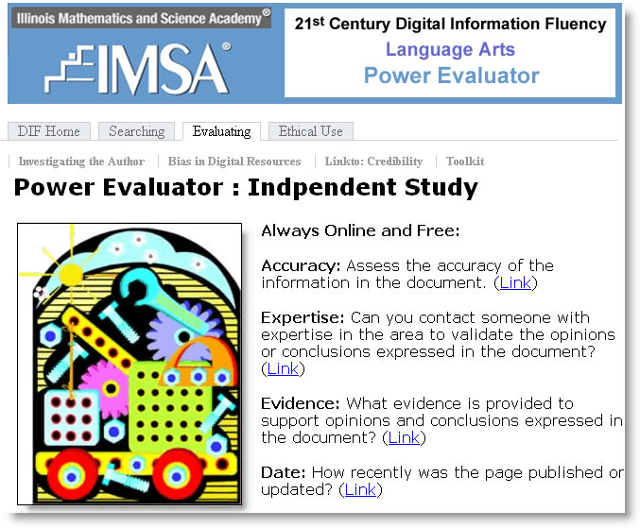
IMSA Core Concepts for Evaluation Addressed by Independent Study:
Learners evaluate the usefulness and quality of digital Information effectively and efficiently.
- Evaluate the quality of a search result to determine its usefulness in the search process
- Evaluate the quality of a search result to determine the reliability of its content

To promote independent study or to customize training for those students who pass the initial challenges use the Power Evaluator Independent Study material found under the Toolkit tab.

Each module has a pre and post test. Many of the modules are supplemented with multimedia sound tracks and streaming video tutorials. While these topics are not addressed directly in the DIF Investigator training, these IMSA MicroModules will help deepen your students understanding of ethical use of digital information.

Links to Independent Study MicroModules

Alphabetical List of All Modules: (Link) | Expertise: (Link)
Accuracy: (Link) | Links From: (Link)
Date: (Link) | Publisher: (Link)
Evidence: (Link) | Traditional Sources: (Link)

 | Publisher: How reliable is the publisher (site) of the web page?  Ask yourself these questions:  - Is this a national or international organization?  - What is the mission of the organization?  - Is this site sponsoring the author's page or just providing web space?  - Does the site provide a contact for further information?

Why? The organization that sponsors a site can sometimes provide clues for further investigation. Educational, non-profit and commercial sites tend to sponsor different kinds of information. However, the sponsoring organization is no guarantee of quality.

How? Identify the domain of the site (What do the last letters of the URL, .com, .edu, .org imply?). Look for "about this site" links and follow them to find what the organizations have to say about themselves.
Backtracking through the hierarchy of the URL will often take you to the main home page of the organization where you might find this kind of information.

Expertise: Can you contact someone with expertise in the area to validate the opinions or conclusions expressed in the document?

Ask yourself these questions:
- Do you know someone with experience or expertise on this topic?
- Do you know someone who could refer you to an expert on the topic?
- Can you find someone online whose credibility on this topic is well established?

Why? Seeking at least three sources for information (sometimes called triangulation) is a dependable way to be sure that you are getting the whole story and not just part of the story, particularly if the subject is a complex one.

How? Search for the authors of other web pages who have written about this topic and contact them via email. Ask your librarian or teacher or someone else you know who is interested in the topic.

Evidence: What evidence is provided to support opinions and conclusions expressed in the document?

Ask yourself these questions:
- Does the author provide data to support each important opinion or conclusion?
- Is the data quantitative or qualitative?
- Is the evidence supported by references to accepted authorities on the topic?
- Is there information on the page that would allow you to contact the author or publisher to check the information?

Why? Opinions and conclusions are only as credible as the arguments and evidence used to support them. The amount, quality and logic of the evidence is a key to the reliability of the information presented in a web page.

How? Look for verifiable facts or references to authoritative sources that can help you determine the credibility of the argument or information. Cross reference the information to other sources. But in the end, you will have to use your own critical thinking skills to sort out fact from opinion and logical argument from emotional appeals.

Date: How recently was the page published or updated?

Ask yourself these questions:
- Does the date of publication affect the reliability of the information?
- Does the date the document was updated affect the reliability of the information?
- How accurately can you determine the date of publication or updating?

Why? It is important to know whether the information you have found is current or outdated. Much information on the web is not updated after it is originally published, and it is harder to determine when web information was published or updated.

How? Look at the bottom of a web page to see if the author has indicated when the page was last updated. Authors and web-masters typically put update information there. If you are using the Netscape browser, you can use the "Page Info" option under the View menu to see information about when the document was last modified on the server where it resides.

Accuracy: Assess the accuracy of the information in the document.

Ask yourself these questions:
- Is the content of the site a true reflection of what it says it is?
- Are the facts correct?
- Is there a way to judge accuracy, such as independent access to information upon which the site is based?
- Are there typographical or grammatical errors?

Why? The accuracy of factual information can tell you something about the care the author took in preparing the document and can provide clues to possible bias in the perspective represented in the document.

How? Cross check factual data with other documents on the web by searching for other pages containing information about the facts. Even checking spelling and grammar can sometimes provide a clue about the care taken in creating a document.

Site Resources: How reliable are the outside resource pages the author chooses to use?

Ask yourself these questions:

- Do these pages support or contradict facts or opinions on the author's page?
- Do these pages add any new information on the topic?
- Are the pages on another site or the same site?
- Are the pages from the same or a different domain?

Why? Links to other pages are like footnotes in a hard copy document, they can provide a context for evaluation. They can tell you how the author supports his argument and what other information he or she considers important.

How? To find the resources a website values look for links with titles like Links or Resources.

Traditional Sources: What information on the topic is available from traditional sources such as newspapers, magazines, encyclopedias or library resources on the web?

Ask yourself these questions:
- Do these pages support or contradict facts or opinions on the author's page?
- Do these pages add any new information or perspective on the topic?
- Are these sources likely to be more reliable than the author's page?

Why? Pages on the web that are published by traditional publishers or by libraries have been through the traditional evaluation process before being published and provide a more dependable standard for evaluating an author or a page.

How? Check out libraries, professional associations, biographies, bibliographies, encyclopedias and the like online. Look for publications by the author or organization in traditional formats.
Appendix A: Who is the Author?
 | Why would you want to know who authors a web page?  Web pages do not undergo the same rigorous editorial process used to create published books, magazines and newspapers. In traditional publishing, peer review, and fact checking are part of the process. Background checks are run to assure that authors know what they are writing about. By contrast, web publishing is less formal, and by implication the information published on the web is less likely to be thoroughly verified. It is up to the reader to check a web page author's credentials. Investigating the author will help you to trust the credibility of the information found on a web page.

Where will you find an author's name?
Sometimes the author's name is prominently displayed at the top or bottom of the web page. Most of the time, you will have to dig for this information. Author information is often found on an "About this Site" page. Once you have the author's name, use it to search for additional writing and biographical information on the site and elsewhere. You can also use a search engine to research the author's background. Sometimes there will be no author's name, which makes it difficult to judge the credibility of the information you seek.

How can you learn more about an author's expertise on a particular subject?
Enter the author's name in a search engine. Pair subject keywords with the author's name to search subject specific databases on the invisible web. This is when you should use lots of synonyms, hypernyms, and hyponyms to find out how much the author knows about the subject. Does the author just know enough to use the latest popular terms, or does s/he really understand the entire field of study?

What Questions should I ask when evaluating the author of a web page?
Let these questions guide your evaluation of a web page author:
● Who is the author of the web page?
● How much experience does the author have in this area?
● What is the author's occupation?
● What is the author's educational background?
● What is the author's reputation among others in the field?

Example 1. Who is the author of the following web page? What can you find out about the author using basic investigation techniques?
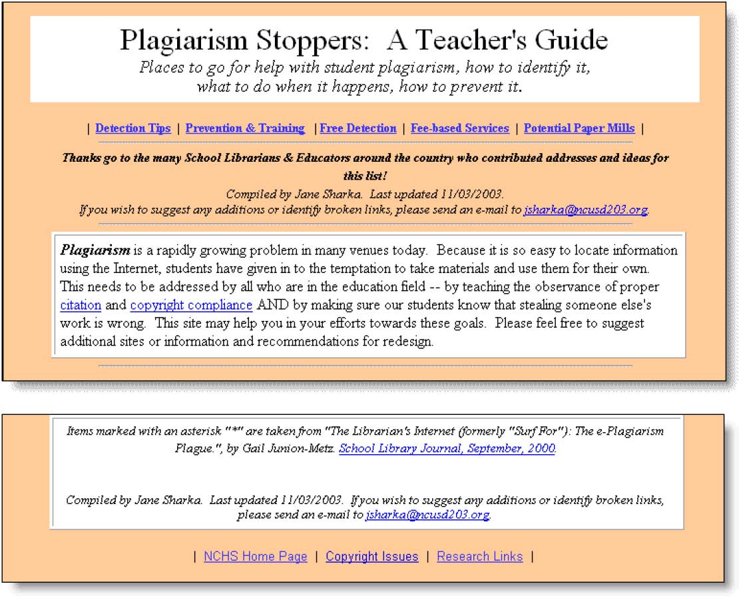
Plagiarism Stoppers: A Teacher's Guide was authored by Jane Sharka, though she doesn’t take credit as she thanks librarians and educators for sharing content. She is a Library Media Specialist at the North Central Unified School District 203 in Illinois, USA. However this information isn't immediately obvious when viewing this page. Her email address indicates she works for a school district. I just happen to know it is an Illinois district. I followed the link at the bottom of the page to the NCHS Homepage. From there I used the site map to find a staff email list. That is where I found Ms. Sharka's job title and contact information. We have no idea how long Jane has been a Library Media Specialist or what her training/credentials are. We do know that she uses a reputable publication, The School Library Journal, as a source for some of the information on this page.

What should I try to find out about an author of a web page?
The qualifications a good web page author are the same as a good book or journal author. Keep these questions in mind as you investigate:
● Who is the author of the web page?
● How much experience does the author have in this area?
● What is the author's occupation?
● What is the author's educational background?
● What is the author's reputation among others in the field?

Example 2. Who is the author of the following web page? What can you find out about the author by looking at the pages and searching the website?
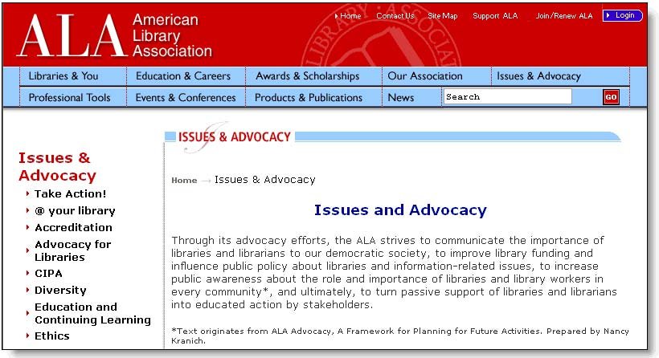
Nancy Kranich is the author of the paragraph (or is it just part of the paragraph) on the ALA web page. However, the byline says she prepared the text. Is that the same as authored? Who wrote the book A Framework for Planning for Future Activities? Is it a book? Is it maybe a pamphlet written by someone else for the American Library Association? This page tells us nothing about Nancy except that she might have written a book or pamphlet called A Framework for Planning for Future Activities that deals with library issues and advocacy

Detective Work: Searching within a Site
Some websites provide a site-search engine. Additionally, some search engines have a feature that lets you to search within a site. Either way, you can use keywords like the author's name to quickly find information about what an individual author has contributed to a web site. To find out more about Nancy Kranich and her qualifications you'll have to dig a little deeper. See how we did it by viewing the (online) Video Tutorial!

 | Detective Work: Truncating the URL  You can learn more about the site you are visiting by truncating the URL. Truncating the URL is a way to navigate through a website by backtracking through the web address. Search engines will sometimes drop you deep within the navigational structure of a website. If you want to find out more about the host site, you can systematically delete elements of the web address (URL). With each 'truncation' you arrive at a new page. By truncating the URL, you may find other resources created by the author you are investigating. You'll certainly learn a bit more about the website that has published the resource

Who is the author of this Micro Module?
My name is Lora K. Kaisler. I have 24 years of experience in education as a teacher, professional developer, researcher, and administrator. I am the Coordinator of Online Learning and Research at the Illinois Mathematics and Science Academy, Aurora, Illinois. I hold a BA in elementary and music education, an MS in special education K-12, and an MA in instructional design and technology. My students tell me my classes are hard but worth it. My colleagues tell me my classes use "a combination of project-based learning and personal reflection to generate an appreciation of processes over content". Work colleagues tell me I am very helpful and always available when things come up.
If you'd like to know more the authors of this module, consider using truncation and site search tools on the 21st Century Information Fluency Portal!
Appendix B: Indicators of Bias
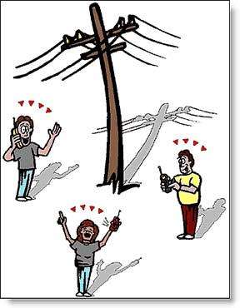 | What is Bias?  This is how the Merriam-Webster Online Dictionary defines bias:  BENT , TENDENCY b : an inclination of temperament or outlook; especially: a personal and sometimes unreasoned judgment: PREJUDICE c :an instance of such prejudice d (1): deviation of the expected value of a statistical estimate from the quantity it estimates (2): systematic error introduced into sampling or testing by selecting or encouraging one outcome or answer over others
Here's what Roget's II: The New Thesaurus, Third Edition says:

Exhibiting bias: biased, one-sided, partisan, prejudiced, prejudicial, prepossessed, tendentious. See LIKE, STRAIGHT. 2. Disposed to favor one over another: favorable, preferential.

When it comes to modern media like news, advertising and the Internet, bias on demand has become the profession of spin-doctors who specialize in spinning anything negative into something positive.

Why should we check the bias of information on a web page?
Would you trust information unsupported by facts or logical reasoning? A biased author may not pay attention to all the facts or develop a logical argument to support his or her opinions.

Bias is when a statement reflects a partiality, preference, or prejudice for or against a person, object, or idea. Much of what you read and hear expresses a bias. Bias is when a writer or speaker uses a selection of facts, choice of words, and the quality and tone of description, to convey a particular feeling or attitude. Its purpose is to convey a certain attitude or point of view toward the subject. As you read or listen to biased materials, keep the following questions in mind:

- What facts has the author omitted?
- What additional information is necessary?
- What words create positive or negative impressions?
- What impression would I have if different words had been used?

Biased information tries to change your mind, how you think. Being aware of bias and knowing how to identify, analyze, and assimilate biased information properly is a skill to be treasured. It puts you in charge of how you think instead of the print and media world. (Cuesta College Critically Evaluating the Logic and Validity of Information)

What are some indicators of bias on a web page?

The language of the document is often extreme; statements have all or nothing connotations. The argument appeals more to the emotions than to logic. Things are worded with the intent to oversimplify or over generalize. The author wishes to present a limited view of the topic. You should expect bias on webpages that are dedicated to selling you something. Additionally, webpages dedicated to controversial topics are likely to have a bias.

Questions to keep in mind as you seek indicators of bias:
● What is the author's political point of view?
● What does the author stand to gain?
● Who is paying for the website?
● Does the author present alternate points of view?
- If so, are those views presented objectively, or with scorn?

Propaganda Techniques Work on the Web: Indicators of Bias
Propaganda is the dark side of bias. Propaganda techniques are designed to influence opinion by manipulating the truth. A propagandist is completely biased in favor of some point of view.

Knowing propaganda techniques will help you analyze webpages, understand advertising, and recognize bias when you see it.

Authors who use name-calling and strive to evoke fear are using tried and true propaganda techniques. Appealing to the group, using glittering generalizations, and relying on testimonials are very persuasive techniques, especially if the audience is unaware of how propagandists operate.

Appendix C: Links To: How can the websites that link to a certain web page tell us whether or not that web page is reliable?
What is a links to search?

Would you like a report on all websites that link to a webpage you are evaluating? Would this information help you judge a web page?
If other reputable authors or organizations have links to a web page, it suggests that others have evaluated it positively. If reliable sources have links to a web page as a reference, chances are better that that web page is also a reliable resource.
On the other hand, if disreputable, unknown, or spam-type sources link to the web page, you have a clue that this web page might not be so reliable.
How do I find out who has links to a specific web page?
Many search engines have specialized links to features. This feature is usually found on the advanced search page.
Think of a search engine's links to feature like a detective's tool. Detectives use special tools to uncover hidden information. The links to tool can tell you a lot about the quality of a website. BEWARE: Each search engine has slightly different rules. The spacing and spelling for a links to search varies depending on which search engine you are using. Plan to investigate your favorite search engine to learn the nuances of using its links to tool.
Does all this sound complicated? Perhaps a bit, but remember that detectives are persistent and willing to put in the leg work needed to get the information they are looking for! In the pages that follow, we will walk you through a couple searches and give you a chance to take a close look at how the links to feature works.
See How a links to Search is Built
The IMSA Search Wizard is designed to help detectives learn to use the tools of their trade. One feature helps you do a links to search. Under Special Features, you'll see the phrase: Link operator. Enter this web address in the box: http://www.islma.org and watch the query form in the search box at the bottom of the page.
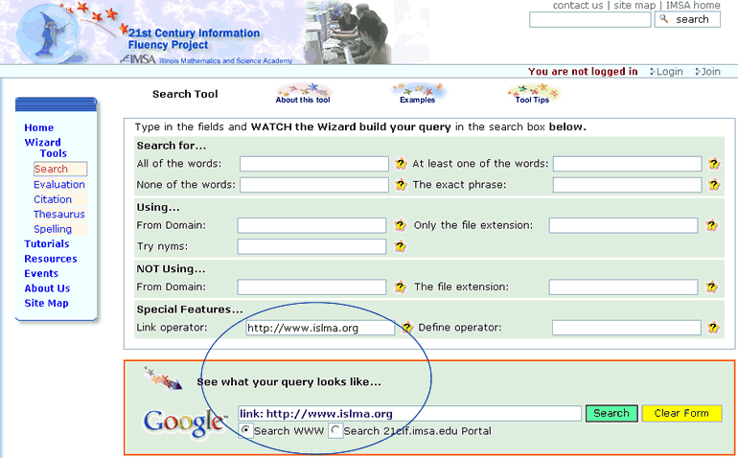
Note that the Search Wizard first places the operator link: in the search box. Also, do you detect the space between the colon and the web address you are investigating? As you will see, that space means a lot! Click the Search button and you'll see all of the pages that link to the Illinois School Library Media Association!

How does Google do it?
Google's Advanced Search page has a number of detective tools. Scroll down the page a bit and locate the area called Page-Specific Search. When you use this form, just enter the web address (also called the URL) http://www.islma. org and click
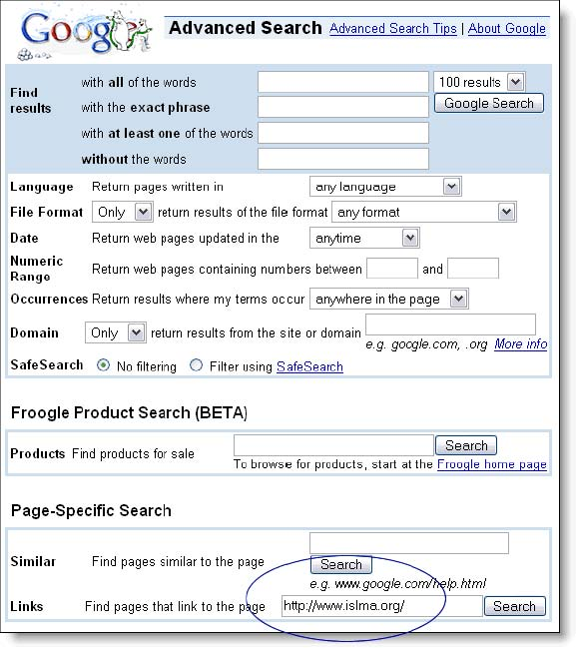

The Game's Afoot! Time to Detect!
Once you execute your Google Advanced links to Search you'll see a results page. The page lists other pages with links to the page you are investigating. Scan the snippets. Think about the nature of the websites that have chosen to link to the page under investigation. Now's the time for critical judgment.
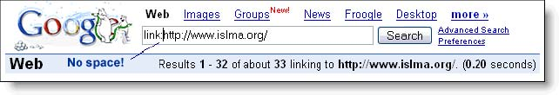
When your results display, look at the address bar. You'll see that Google has inserted the Link: operator and your query in the address bar. Note the number of results you have.
Let's push things a bit farther. Experiment by adding a space after the colon and repeating the search. This new search reveals even more links to the page we are investigating. What a difference a space makes! When evaluating websites by using a links to search in Google, you can greatly expand your results by simply adding a space between the link: operator and the URL. It pays to be a persistent detective!
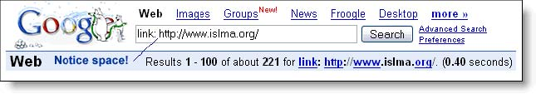

An example of a links to search
We used the links to tool to find websites that link to the Illinois School Library Media Association (http://www.islma.org ).
Here's a sample of the sites that came up in our links to search:
● Spring Brook Elementary School - Library Media Center
● Professional Teacher.com
● The Latin School of Chicago
● Ask ERIC
● Rich Central High School

Our observations about these results are:
- Websites linking to the page under investigation are from educational ventures and organizations.
- These sites have to do with library services and information fluency ideas.
- These sites offer additional information about library services in Illinois.

Evaluating the results of a links to search.
Ask yourself these questions:
● Are the pages linking to this resource credible or authoritative?
● Do the pages linking to this resource support or contradict facts or opinions expressed on the web page?
● Do these pages add any new information or perspective on the topic being presented on this web page?
● Are the linked pages on the same or different sites?
● Are the linked pages in the same or different domains (org, .edu, .gov)?

The answers to these questions help us determine whether or not to use the web page as a resource and how much value we should place on its credibility.

Dig Into your Favorite Search Engine!
Now it's your turn. Many search engines have specialized links to features. Dig down into your favorite search engine and experiment to better understand how its links to tool works. As we noted earlier, this feature is usually found on the advanced search page. And remember that sometimes different tools mean slightly different rules!

